Golden Horn Elementary School

209 Duncan Drive, Whitehorse, Yukon Y1A 7A1

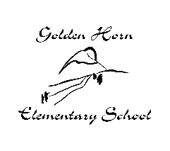
867-667-8130

Principal: Darcy LeBlanc Darcy.LeBlanc@gov.yk.ca
Vice-Principal: Jesse Ward Jesse.Ward@gov.yk.ca
Secretary: Jean Nikon Jean.Nikon@gov.yk.ca

School Supplies 2019-2020

Grade 4: Krista John

Quantity | Purchase Item
1 | Backback or school bag, large enough to hold duo-tangs, books and lunch kits
1 | Lunch Kit
1 | Water Bottle
1 | Box of Kleenex
1 | Indoor shoes – Velcro or laces (only if child is able to tie them)  (non-marking soles, appropriate for physical education)
1 | Pencil case
1 | Headset or ear buds for technology
1 | Fidget Tool
Quantity | Fee Item
$ 70 | The teacher will purchase the following materials: binders, sharpies, crayons, pencil crayons, pens, pencils, erasers, markers, paper, art supplies, etc.
$ 50 | Activity Fee for Learn to Swim Lessons (8 Lessons)
Cheques can be made out to Golden Horn Elementary School or e-transfer to GHES@gov.yk.ca (indicate teacher name, grade, student name and what it is for).

Please send items the first day of school clearly labelled with student name.

*PLEASE NOTE: ADDITIONAL SUPPLIES AND FEES MAY BE REQUIRED THROUGHOUT THE YEAR

