Golden Horn Elementary School

209 Duncan Drive, Whitehorse, Yukon Y1A 7A1

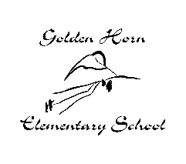
867-667-8130

Principal: Darcy LeBlanc Darcy.LeBlanc@gov.yk.ca
Vice-Principal: Jesse Ward Jesse.Ward@gov.yk.ca
Secretary: Jean Nikon Jean.Nikon@gov.yk.ca

School Supplies 2019-2020

Grade 2: Ms. Agnew

Quantity | ITEM
1 | Packsack or school bag, large enough to hold duo-tangs, books and lunch kits
1 | Water bottle
1 | Box of Kleenex
1 | Indoor shoes – Velcro or laces (only if child is able to tie them)  (non-marking soles & non-wheely, appropriate for physical education)
 | FEES
$60 | The teacher will purchase the following materials: pencils, erasers, crayons, pencil crayons, markers, duo-tangs, binders, notebooks, art supplies, back and forth bags, scissors, glue, etc.
$40 | Activity fee for swimming, Swan Haven, and Dessert in the Desert year end trip.
Cheques can be made out to Golden Horn Elementary School or e-transfer to GHES@gov.yk.ca (indicate teacher name, grade, student name and what it is for).

Please make payment for fees within the first week of school.

*PLEASE NOTE: ADDITIONAL SUPPLIES AND FEES MAY BE REQUIRED THROUGHOUT THE YEAR

